- Melbin (1 and 11.A)

- Meria (2 and 11.B)

- Merin (3 and 12.A)

- Midhu (4 and 12.B)

- Neelima (5 and 13.A)

- Neenu (6 and 13.B)

- Neethu (7 and 14.A)

- Neha (8 and 14.b)

- Nidhiya(9 and 15.A)

- Nikita (10 and 15.B)

1. Explain the keyboard display interface in brief ?

(figure)

8279 is a hardware approach to interfacing a matrix keyboard and a multiplexed display that scans and encodes upto a 64-key keyboard and controls upto a 16-digit numerical display.. It is a 40-pin device with two major segments keyboard and display. The keyboard segment can be connected to a 64 contact key matrix. The keyboard entries are debounced and stored in the internal FIFO memory; and an interrupt signal is generated with each entry. The display segment can provide a 16-character scanned display interfaces with devices like LED’s. This segment has 16*8 R/W memory, which can be used to read or write information for display purposes.

- A programmable keyboard and display interfacing chip.
- Scans and encodes up to a 64-key keyboard.
- Controls up to a 16-digit numerical display.
- Keyboard has a built-in FIFO 8 character buffer.
- The display is controlled from an internal 16x8 RAM that stores the coded display information.
Keyboards consist of a large matrix of keys, all of which are monitored by an on-board processor called the "keyboard encoder". The specific processor varies from keyboard-to-keyboard but they all basically do the same thing: Monitor which key(s) are being pressed/released and send the appropriate data to the host. This processor takes care of all the debouncing and buffers any data in its 16-byte buffer, if needed.
Motherboard contains a "keyboard controller" that is in charge of decoding all of the data received from the keyboard and informs software of what's going on.

2. Explain the modes of operation of 8251.
A:
8251 processor has mainly two modes of operations
- Asynchronous mode
- Synchronous mode

To change the mode of operation from synchronous to asynchronous or vice versa, the 8251 has to be reset using master chip reset.

Asynchronous mode

Mode instruction control word :This defines the general operational characteristics of 8251A. After internal or external reset, this must be written to configure the 8251 as per the required operation. Once this has been written into 8251, SYNC characters or command instructions may be programmed further as per the requirements.

Asynchronous mode transmission: When a data character is sent to 8251 by the CPU, it adds start bits prior to the serial data bits, followed by optional parity bit and stop bits using the asynchronous mode instruction control word format. This sequence is then transmitted using TXD output pin on the falling edge of TXC. When no data characters are sent by CPU to 8251 the TXD output remains high, if a break has not been detected.

Asynchronous mode receive: A falling edge on RXD input line marks a start bit. The bit counter locates the data bits, parity bit and start bit. RXRDY pin is raised high to indicate to the CPU that a character is ready for it.The receiver requires only one stop bit to mark the end of the data bit string.

Synchronous mode

Synchronous mode transmission: The TXD output is high until the CPU sends a character to 8251 which usually is a SYNC character. When CTS line goes low, the first character is serially transmitted out.

Synchronous mode receiver: In this mode, the character synchronization can be achieved internally or externally.

3. Explain what do you mean by (1) debouncing a switch input (2) 2-key lockout.

When a mechanical pushbutton is pressed or released the metal contacts of the key momentarily bounce before giving a steady state reading.therefore it is necessary that the bouncing of the key should not be read as an input.The key bounce can be eliminated from the input data by key debounce technique,using either hardware or software.
Figure
In this circuit the outputs of the NAND gates do not change even if the key is released from position A1.The outputs change when the key makes contacts with position B1.When key is connected to A1,it goes low.If one of the inputs of gate G1is low,the output O1 becomes 1,which makes B2 high.Because line B1 is already high,the output of O2 goes low,which makes A2 low.When the key connection is released from A1,it goes high,but because A2 is low the output doesn’t change.When the key makes contact with B1,the outputs change.This means when the key goes from one contact to another contact the output doesn’t change during the transition period thus eliminating multiple readings.

2-key lockout

In this mode of operation ,when the key is pressed a debounce logic comes into operation.During the next two scans ,other keys are checked for closure and if no other key is pressed the first pressed key is identified.The key code identified is entered into the FIFO with SHIFT and CNTL status,provided the FIFO is not full i.e it has atleast one byte free.If the FIFO doesn’t have any free byte,the key data will not be entered and the error flag is set.when the code is entered the 8279 generates an interrupt to the CPU to inform about the previous key closures.
If another key is found closed during the subsequent two scans no entry to FIFO is made.If all other keys are released before the first key key code is entered into FIFO.A keycode is entered into the FIFO only once for each valid depression independent of other keys pressed along with it.If two keys are pressed within a debounce cycle no key is recognized till one of them remains closed and the other is released.The last key that remains depressed is considered as single valid key expression.

4.What are the architechtural differences between a microprocessor and a microcontroller?
A:The microprocessor is the integration of a number of useful functions into a single IC package. These functions are:
- The ability to execute a stored set of instructions to carry out user defined tasks.
- The ability to be able to access external memory chips to both read and write data from and to the memory.
A stand alone microprocessor is not a self sufficient device. It requires other components like memory and input output devices to form a minimum workable system configuration. To have all these components in discrete form and to assemble them on a PCB, most of the times is not an affordable for the following reasons.
1. The overall system cost of the microprocessor based system built around a CPU, memory and other peripherals is high as compared to a microcontroller based system.
2. A large PCB is required for assembling all these components resulting in an enhanced cost of the system.
3. Design of such PCB requires a lot of effort and time and thus the overall product design requires more time.
4. Due to large size of PCB and discrete components used, physical size of the product is big and is not handy.
5. As discrete components are used, the system is not reliable nor is it easy to troubleshoot such a system.

But, a microcontroller is a device which integrates a number of the components of a microprocessor system onto a single microchip.It is a computer-on-a-chip.
So a microcontroller combines onto the same microchip:
- The CPU core
- Memory (both ROM and RAM)
- Some parallel digital I/O
It is a type of microprocessor emphasizing self-sufficiency and cost-effectiveness, in contrast to a general-purpose microprocessor. The only difference being in a microcontroller and a microprocessor is that a microprocessor has three parts - ALU, Control Unit and registers (like memory), but the microcontroller has additional elements like ROM, RAM etc.
In contrast to general-purpose CPUs, microcontrollers do not have an address bus or a data bus, because they integrate all the RAM and non-volatile memory on the same chip as the CPU. Because they need fewer pins, the chip can be placed in a much smaller, cheaper package.
Integrating the memory and other peripherals on a single chip and testing them as a unit increases the cost of that chip, but often results in decreased net cost of the embedded system as a whole.

5. Draw the schematic diagram of Intel 8086 registers and explain.
Ans: The 8086 processor consist of four 16 bit general-purpose registers and index registers. It also provides a 16 bit flag register to keep up the status of operation.

General Purpose Registers

All general registers of the 8086 microprocessor can be used for arithmetic and logic operations. The diagram is shown below.
AH | AL
BH | BL
CH | CL
DH | DL
SP
BP
SI
DI

The general registers are:
a) Accumulator
Accumulator register consists of 2 8-bit registers AL and AH, which can be combined together and used as a 16-bit register AX. AL in this case contains the low-order byte of the word, and AH contains the high-order byte. Accumulator can be used for I/O operations and string manipulation.
b) Base register
Base register consists of 2 8-bit registers BL and BH, which can be combined together and used as a 16-bit register BX. BL in this case contains the low-order byte of the word, and BH contains the high-order byte. BX register usually contains a data pointer used for based, based indexed or register indirect addressing.
c) Count register
Count register consists of 2 8-bit registers CL and CH, which can be combined together and used as a 16-bit register CX. When combined, CL register contains the low-order byte of the word, and CH contains the high-order byte. Count register can be used as a counter in string manipulation and shift/rotate instructions.
d) Data register
Data register consists of 2 8-bit registers DL and DH, which can be combined together and used as a 16-bit register DX. When combined, DL register contains the low-order byte of the word, and DH contains the high-order byte. Data register can be used as a port number in I/O operations. In integer 32-bit multiply and divide instruction the DX register contains high-order word of the initial or resulting number.
e) Stack Pointer (SP)
It is a 16-bit register pointing to program stack.
f) Base Pointer (BP)
It is a 16-bit register pointing to data in stack segment. BP register is usually used for based, based indexed or register indirect addressing.
g) Source Index (SI)
It is a 16-bit register. SI is used for indexed, based indexed and register indirect addressing, as well as a source data address in string manipulation instructions.
h) Destination Index (DI)
It is a 16-bit register. DI is used for indexed, based indexed and register indirect addressing, as well as a destination data address in string manipulation instructions.
Then we have a register called Instruction Pointer (IP). It is a 16-bit register.

Flag Register
Flag is a 16-bit register containing 9 1-bit flags:
15 | 14 | 13 | 12 | 11 | 10 | 9 | 8 | 7 | 6 | 5 | 4 | 3 | 2 | 1 | 0
X | X | X | X | OF | DF | IF | TF | SF | ZF | X | AF | X | PF | X | CF
Overflow Flag (OF) - set if the result is too large positive number, or is too small negative number to fit into destination operand.
Direction Flag (DF) - if set then string manipulation instructions will auto-decrement index registers. If cleared then the index registers will be auto-incremented.
Interrupt-enable Flag (IF) - setting this bit enables maskable interrupts.
Single-step Flag (TF) - if set then single-step interrupt will occur after the next instruction.
Sign Flag (SF) - set if the most significant bit of the result is set.
Zero Flag (ZF) - set if the result is zero.
Auxiliary carry Flag (AF) - set if there was a carry from or borrow to bits 0-3 in the AL register.
Parity Flag (PF) - set if parity (the number of "1" bits) in the low-order byte of the result is even.
Carry Flag (CF) - set if there was a carry from or borrow to the most significant bit during last result calculation.
6.Explain instruction pipelining in 8086.

A: The lines QS1,QS0[Queue status] give information about the status of the code-prefetch queue. These are active during the CLK cycle after which the queue operation is performed.
The 8086 architecture has a 6 byte instruction prefetch queue. Thus even the largest (6-bytes) instruction can be prefetched from memory and stored in the prefetch queue. This results in a faster execution of the instructions.In 8085,an instruction(pcode and operand) is fetched ,decoded and executed and only after the execution of this instruction the next instruction is fetched .By prefetching the instruction ,there is considerable speeding up in instruction execution of 8086. This scheme is known as instruction pipelining.
In the beginning, the CS:IP is loaded with the required address from which the execution is to be started. Initially ,the queue will be empty and the microprocessor starts a fetch operation to bring one (first byte) of instruction code,if the CS:IP address is odd or two bytes at a time, if the CS:IP address is even. The first is normally an opcode, these opcodes along with data are fetched and arranged in the queue. When the first byte from the queue goes for decoding and interpretation ,one byte in the queue becomes empty and subsequently the queue is updated. The microprocessor does not perform the next fetch cycle unless atleast two bytes of the instruction queue are emptied. The instruction execution is never broken for fetch operation. After decoding the first byte , the decoding circuit decides whether the instruction is of single or double opcode byte. If its a single opcode byte , the next bytes are treated as data bytes depending on the decoded instruction length, otherwise , the next byte in queue is treated as the second byte of the instruction opcode. The second bye is then decoded in continuation with the first byte to decide he instruction length and number of subsequent bytes to be treated as instruction data. The queue is updated after every byte is read from the queue but hte fetch cycle is initiated by the BIU only if at least two bytes of the queue are empty and the EU may be concurrently executing the fetched instructions.

7.Describe the response a 8086will make if it receives an NMI interrupt during a division operation which produces a divisible by zero interrupt.
[4 marks]

A) NMI stand for non-maskable interrupt.As its name suggests,it is non-B maskable.That is,if an NMI interrupt is received by the processor,it will hav to stop whatever it is executing and execute the interrupt service routine of the NMI.

- If a divide by zero NMI interrupt is received by the 8086 processor while it is executing the program which implements a division operation,the processor finishes the execution of the current instruction cycle of the main program and stores the address of the next instruction in stack and makes the stack pointer point to this location in the stack.

- Then,the flow of control is transferred to the location of the interrupt service routine of the NMI.

- The instructions of the interrupt service routine are executed one after the other until an RET instruction or IRET instruction is encountered by the processor.

- RET or IRET transfers the flow of control back to the main program.The address of the next instruction to be executed is popped from the stack and main program execution continues.

Q 8. Bring out the differences between 8086 and 80286?
A: . The 8086, the first widely used 16-bit microprocessor has been used to power the first IBM PCs. The 8086 has a microprogrammed sequencer, but has also many wired functionalities such as to optimise the size of the microcode. The vertical microinstructions are 21-bit wide. The microprogram ROM contains 504 microinstructions. The architecture of Intel’s first 16-bit processor, 8086 microprocessor is as follows. The 8086 has two independent functional units aimed to work in parallel : the BIU (Bus Interface Unit) and the EU (Execution Unit). Dividing the work between these 2 units speeds up processing.
Flag Registers: Flag is a flip-flop that indicates some condition produced by the execution of an instruction or controls certain operations of the EU. The 16 bit flag register contained 9 active flags. 6 out of 9 (CF, PF,AF,ZF,SF) are known as conditional flags and the other 3 (TF,IF,DF) are known as control flags.
15 11 10 8 6 4 2 0
Bit Definition of 8086 flag register.
The 80286 had 24 address lines making it possible to access 2²⁴ bytes (i.e., 16 Mbytes) of memory (the same as the 68000). The microprocessor had a fairly crude on-chip memory management unit that could be used to support multitasking and virtual memory systems where up to 1Gybtes of virtual memory could be accessed. In order to make the 80286 compatible with software written for the 8086, the 80286 operated in two modes – real and protected. In the real mode, the 80286 looked like an 8086 and could address only 1 Mbyte. In the protected mode, the 80286 could access its entire 16 Mbyte memory space. However, because the protected mode still forced you to use segmentation with 64 Kbyte pages and it was impossible to go from protected to real modes, the protected mode was little used by programmers.The 80286 processor has 8086 register set plus extra registers.
Bus Interface Unit (BIU) adds a Address Unit (AU) which computes the physical address and an instruction unit (IU) having another prefetch queue.Flag registers have two extra entries.Bit 12-13: I/O privilege level (IOPL) and Bit 14: Nested Task (NT) Set = IRET to perform task switch.Machine Status Word (MSW) switch to PVAM and 286 functions.

Q9.What are the various fields in a segment descriptor of 80386?

A) DESCRIPTORS
The segment descriptor provides the processor with the data it needs to map a logical address into a linear address. Here, the access bytes are defined to indicate the stack and code segment description. Segment-descriptor fields are:

Base B₂₄- B₃₁ |  |  |  |  |  |  | G |  | D | 0 | A  V  L | LIMIT L₁₆- L19
P | DPL | S | E | X | RW | A |  | B₁₆- B₂₃
B₀- B₁₅
L₀- L₁₅

P=1: The segment is present.
S=1: Indicate data/Code descriptor.
S=0: System Descriptor
E: Executable- Selects data/Code segment
E=0: Data(Stack) segment
E=1: Code segment
X: Direction of expansion of Data segment.
X=0: Upward as data.
X=1: Downward as stack
RW: E=0 RW=1 DS may be written
E=0 RW=0 DS not written
E=1 RW=1 CS may read.
E=1 RW=0 CS not read
Accessed bit (A): The processor sets this bit each time the segment is accessed.

BASE: Defines the location of the segment within the 4 gigabyte linear address space. The processor concatenates the three fragments of the base address to form a single 32-bit value.

LIMIT: Defines the size of the segment. When the processor concatenates the two parts of the limit field, a 20-bit value results. The processor interprets the limit field in one of two ways, depending on the setting of the granularity bit:
- In units of one byte, to define a limit of up to 1 megabyte.
- In units of 4 Kilobytes, to define a limit of up to 4 gigabytes. The limit is shifted left by 12 bits when loaded, and low-order one-bits are inserted.

GRANULARITY BIT: Specifies the units with which the LIMIT field is interpreted. When the bit is clear, the limit is interpreted in units of one byte; when set, the limit is interpreted in units of 4 Kilobytes.
TYPE: Distinguishes between various kinds of descriptors.
DPL (Descriptor Privilege Level): Used by the protection mechanism

SEGMENT- PRESENT BIT: If this bit is zero, the descriptor is not valid for use in address transformation; the processor will signal an exception when a selector for the descriptor is loaded into a segment register. The operating system is free to use the locations marked AVAILABLE. Operating systems that implement segment-based virtual memory clear the present bit in either of these cases:
- When the linear space spanned by the segment is not mapped by the paging mechanism.
- When the segment is not present in memory.

System Descriptor:
System descriptor defines information about the system tables, tasks and gates.

Base B₂₄- B₃₁ |  |  |  |  | G | D | 0 | A  V  L | LIMIT L₁₆- L19
P | DP | L | 0 | TYPE | B₁₆- B₂₃
B₀- B₁₅
L₀- L₁₅

Descriptor tables
The descriptor table defines all the segments used in the 80386 when it operates in the protected mode. There are three types of descriptor tables: the global descriptor table(GDT), local descriptor table (LDT) and an interrupt vector table(IDT). The registers used by the 80386 to address three tables are called Global descriptor table register(GDTR) the local descriptor table register(LDTR) and the interrupt descriptor table register(IDTR).

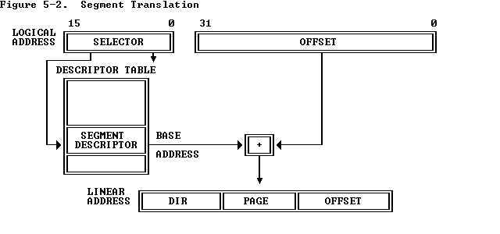
Segment descriptors are stored in either of two kinds of descriptor table:
- The global descriptor table (GDT)
- A local descriptor table (LDT)
A descriptor table is simply a memory array of 8-byte entries that contain descriptors. A descriptor table is variable in length and may contain up to 8192 (2^(13)) descriptors.

Selectors
The selector portion of a logical address identifies a descriptor by specifying a descriptor table and indexing a descriptor within that table

Index: Selects one of 8192 descriptors in a descriptor table. The processor simply multiplies this index value by 8 (the length of a descriptor), and adds the result to the base address of the descriptor table in order to access the appropriate segment descriptor in the table.
Table Indicator: Specifies to which descriptor table the selector refers. A zero indicates the GDT; a one indicates the current LDT.
Requested Privilege Level: Used by the protection mechanism.

10. Explain briefly the 3 different modes of operation of 80386.

- The different modes of operation of 80386 are:
  - REAL MODE:
After reset, the 80386 starts from memory location FFFFFFF0H under the real address mode.In the real mode, 80386 works as a fast 8086 with 32-bit registers and data types.
•In real mode, the default operand size is 16 bit but 32- bit operands and addressing modes may be used with the help of override prefixes.
•The segment size in real mode is 64k, hence the 32-bit effective addressing must be less than 0000FFFFFH.
.The real mode initializes the 80386 and prepares it for protected mode.
Memory addressing in Real mode:
In real mode, 80386 can address at the most1Mbytes of physical memory using address lines A0-A19. •Paging unit is disabled in real addressing mode, and hence real addresses are same as the physical addresses.
•To form a physical memory address, appropriate segment registers contents (16-bits) a
shifted left by four positions and then added to the 16-bit offset address formed using one of the addressing modes, in the same way as in the 80386 real address mode.
•The segment in 80386 real mode can be read, write or executed, i.e. no protection is
available. •Any fetch or access past the end of the segment limit generate exception 13 in real address mode.
•The segments in 80386 real mode may be overlapped or non-overlapped.
•The interrupt vector table of 80386 has been allocated 1Kbyte space startin
00000H to 003FFH.

  - PROTECTED MODE:
All the capabilities of 80386 are available in the protected mode of operation. In this mode , processor has 32 bit address lines.
•The 80386 in protected mode support all the software written for 80286 and 8086 to be executed under the control of memory management and protection abilities of 80386.
•The protected mode allows the use of additional instruction, addressing modes and capabilities of 80386.
ADDESSING IN PROTECTED MODE WITHOUT PAGING
In this mode contents of the segment registers are used as selectors to address descriptors which contain the segment limit, base address and access rights byte of the segment.
•The effective address (offset) is added with segment base address to calculate linear address. This linear address is further used as physical address, if the paging unit is disabled, otherwise the paging unit converts the linear address into physical address.
•The paging unit is a memory management unit enabled only in protected mode. The paging mechanism allows handling of large segments of memory in terms of pages of
4Kbyte size.
•The paging unit operates under the control of segmentation unit. The paging unit if enabled converts linear address to physical address in protected mode.
hence the correct execution of the program.

•Three types of the 80386 descriptor tables are listed as follows: •GLOBAL DESCRIPTOR TABLE ( GDT )
•LOCAL DESCRIPTOR TABLE ( LDT )
•INTERRUPT DESCRIPTOR TABLE ( IDT)

Here, there is memory management and thus, there is virtual memory concept. We need to take only the currently needed segments or pages from the secondary to primary memory. Thus, memory appears to be bigger than actual size.

  - VIRTUAL MODE:
If processor wants to execute an 8086 operation when it is in the protected mode, it has to be restart. This is time consuming and all data is lost.
So, a virtual mode is included here.
In this mode, address space is 1MB. This 1MB can be anywhere in the 4GB memory space. Address calculation is similar to that in real mode.
We can have memory management, virtual memory, segmentation and paging if required.

11.(A)With neat diagram explain the major components of 8279 keyboard/display interface & describe their functions
8279 is a hardware approach to interfacing a matrix keyboard and a multiplexed display that scans and encodes upto a 64-key keyboard and controls upto a 16-digit numerical display.. It is a 40-pin device with two major segments keyboard and display. The keyboard segment can be connected to a 64 contact key matrix. The keyboard entries are debounced and stored in the internal FIFO memory; and an interrupt signal is generated with each entry. The display segment can provide a 16-character scanned display interfaces with devices like LED’s. This segment has 16*8 R/W memory, which can be used to read or write information for display purposes.

Programmable Keyboard/Display Interface - 8279
- A programmable keyboard and display interfacing chip.
  - Scans and encodes up to a 64-key keyboard.
  - Controls up to a 16-digit numerical display.
- Keyboard has a built-in FIFO 8 character buffer.
- The display is controlled from an internal 16x8 RAM that stores the coded display information.
Keyboards consist of a large matrix of keys, all of which are monitored by an on-board processor called the "keyboard encoder". The specific processor varies from keyboard-to-keyboard but they all basically do the same thing: Monitor which key(s) are being pressed/released and send the appropriate data to the host. This processor takes care of all the debouncing and buffers any data in its 16-byte buffer, if needed.
Motherboard contains a "keyboard controller" that is in charge of decoding all of the data received from the keyboard and informs software of what's going on.

Functional block diagram of 8279

DB₀-DB₇
Data Bus Buffer
FIFO/ Sensor RAM Status
Timing &
Control
Display
Register
Beyboard debounce
& Control
8 * 8 FIFO/ Sensor RAM
16 * 8 Display RAM
Display Addr Reg
Return
Scan Counter
I/O Control

8

CLK RESET IRQ

Control & Timing Reg

Pinout Definition of 8279
- A0: Selects data (0) or control/status (1) for reads and writes between micro and 8279.
- BD: Output that blanks the displays.
- CLK: Used internally for timing. Max is 3 MHz.
- CN/ST: Control/strobe, connected to the control key on the keyboard.
- CS: Chip select that enables programming, reading the keyboard, etc.
- DB7-DB0: Consists of bidirectional pins that connect to data bus on micro.
- IRQ: Interrupt request, becomes 1 when a key is pressed, data is available.
- OUT A3-A0/B3-B0: Outputs that sends data to the most significant/least significant nibble of display.
- RD(WR): Connects to micro's IORC or RD signal, reads data/status registers.
- RESET: Connects to system RESET.
- RL7-RL0: Return lines are inputs used to sense key depression in the keyboard matrix.
- Shift: Shift connects to Shift key on keyboard.
- SL3-SL0: Scan line outputs scan both the keyboard and displays

The functional block diagram of 8279 has four major sections
    - Keyboard
    - Scan
    - Display
    - CPU Interface
Keyboard section consists of eight return lines RL0-RL7, that can be used to form the columns of a keyboard matrix. It has two additional inputs shift and control/strobe. The keys are automatically debounce. It also has a 8X8 FIFO RAM. It can store 8 keycodes. The status of the shift and control key are also stored along with keycode. 8279 generates an interrupt signal when there is an entry on FIFO.
Display section has eight output lines divided into two groups A0-A3 and B0-B3. The output lines are connected to the anodes through driver transistor in case of common cathode 7 segment LED. The display can be blanked by BD line. The display section consists of 16X 8 display RAM which can also be organized into dual 16X4. The CPU load the display codes in this RAM.
Scan section has a scan counter and four scan lines, SL0-SL3. The scan lines are used to form the rows of a matrix keyboard and the digit drivers of a multiplexed display.
CPU interface takes care of data transfer between 8279 and the processor. This section has eight bi-directional data lines DB0-DB7 for data transfer.
When a key is pressed it bounces for a short time. If a key code is generated immediately after sensing a key actuation, then the processor will generate the same keycode a number of times. A key typically bounces for 10 to 20 ms. Hence the processor has to wait for the key bounces to settle before reading the keycode.
Interfacing a matrix keyboard with 8085

A matrix keyboard is where there are more than eight keys. A keyboard with 16 keys can be arranged in a 4 x 4 matrix. It requires eight lines from the microprocessor to make all the connections. When a key is pressed, it shorts one row and column. The interfacing of a matrix keyboard requires two ports: one output port and one input port. Rows are connected to the output port and the columns are connected to the input port.

1. Ground all the rows by sending logic 0 through the output port
2. Check the columns by reading the input port. If no key is pressed, all columns remain high. Continue the above two steps until the reading indicates a change
3. When one of the keys is pressed, the corresponding column goes low; identify and encode the key

The columns and rows make contact only when a key is pressed. Otherwise it remains high. When the key is pressed, the intersection of row and column must change from high to low. The column lines of the keyboard are connected to the return lines, RL0-RL7 of 8279. As a low is put on each row, the 8279 checks these return lines one at a time to see any of them is low. If it finds any of return lines low, indicating a keypress, it waits a debounce time of about 10.3 ms and checks again. If keypress is still present, the 8279 produces an 8-bit code to represent the pressed key. After sending the packet information of pressed key, it stores the byte in an internal FIFO RAM. IT also asserts the IRQ pin high and increment the FIFO count in the internal status register.

Scan Codes
The keyboard's processor spends most of its time "scanning", or monitoring, the matrix of keys. If it finds that any key is being pressed, released, or held down, the keyboard will send a packet of information known as a "scan code" to the computer.
There are two different types of scan codes: "make codes" and "break codes". A make code is sent when a key is pressed or held down. A break code is sent when a key is released. Every key is assigned its own unique make code and break code so the host can determine exactly what happened to which key by looking at a single scan code. The make code only represents a key on a keyboard--it does not represent the character printed on that key. This means that there is no defined relationship between a make code and an ASCII code. It's up to the host to translate scan codes to characters or commands.

Interfacing keyboard and a seven segment LED to 8085

A pushbutton keyboard is connected to port A and a seven segment Led is connected to port B of 8255. Port A should be configured as an input port and port B as an output port

- Analyse the address decoding circuits and find the address of port A, port B and control register
- Write the appopriate control word to the control register to configure the ports as required.
- Check if a key is pressed- write the software program to do it
- Debounce the key- hardware soln- use of cross coupled NAND gate and software soln is to write a delay loop
- Identify the key pressed- write the ALP to store the identified key in the accumulator
- Encode the key – converts the binary hardware reading of the key 0pressed into appropriate binary format according to the number of the key
- Obtain the seven segment LED code using table look-up technique and display it

Q11(B) Draw and explain the internal architecture of 8255.Explain the command word in all the modes.
A:

8255A is a general purpose, programmable, parallel I/O device. It has 24 I/O pins that can be grouped primarily in two 8-bit parallel ports: A and B, with the remaining eight bits as port C. The eight bits of port C can be used as individual bits or can be grouped in two 4-bit ports: C_{upper} & C_{lower}. The functions of these ports are defined by writing a control word in the control register.

8255A I/O ports

Port A

8255A

C_{u}
C_{l}

Port B

Architecture

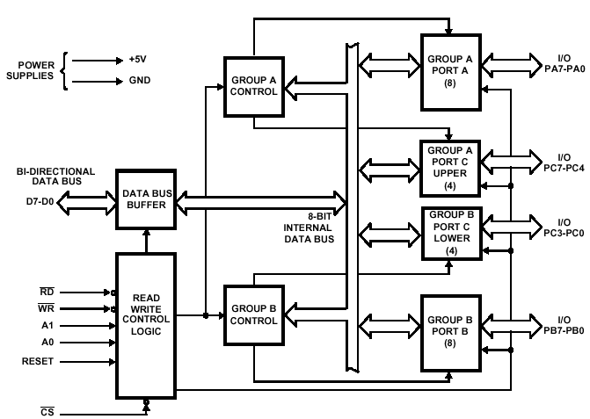

Data Bus Buffer
This three-state bi-directional 8-bit buffer is used to interface the 8255 to the system data bus. Data is transmitted or received by the buffer upon execution of input or output instructions by the CPU. Control words and status informa-tion are also transferred through the data bus buffer.

Read/Write and Control Logic
The function of this block is to manage all of the internal and external transfers of both Data and Control or Status words. It accepts inputs from the CPU Address and Control busses and in turn, issues commands to both of the Control Groups.
(CS) Chip Select. A "low" on this input pin enables the communcation between the 8255 and the CPU.
(RD) Read. A "low" on this input pin enables 8255 to send the data or status information to the CPU on the data bus. In essence, it allows the CPU to "read from" the 8255.
(WR) Write. A "low" on this input pin enables the CPU to write data or control words into the 8255.
(A0 and A1) Port Select 0 and Port Select 1. These input signals, in conjunction with the RD and WR inputs, control the selection of one of the three ports or the control word register. They are normally connected to the least significant bits of the address bus (A0 and A1).
(RESET) Reset. A "high" on this input initializes the control register to 9Bh and all ports (A, B, C) are set to the input mode.

A1 | A0 | SELECTION
0 | 0 | PORT A
0 | 1 | PORT B
1 | 0 | PORT C
1 | 1 | CONTROL

Group A and Group B Controls

The functional configuration of each port is programmed by the systems software. In essence, the CPU "outputs" a control word to the 8255. The control word contains information such as "mode", "bit set", "bit reset", etc., that initializes the functional configuration of the 8255. Each of the Control blocks (Group A and Group B) accepts "commands" from the Read/Write Control logic, receives "control words" from the internal data bus and issues the proper commands to its associated ports.

Ports A, B, and C

The 8255 contains three 8-bit ports (A, B, and C). All can be configured to a wide variety of functional characteristics by the system software but each has its own special features or "personality" to further enhance the power and flexibility of the 8255.

Port A One 8-bit data output latch/buffer and one 8-bit data input latch. Both "pull-up" and "pull-down" bus-hold devices are present on Port A.

Port B One 8-bit data input/output latch/buffer and one 8-bit data input buffer.

Port C One 8-bit data output latch/buffer and one 8-bit data input buffer (no latch for input). This port can be divided into two 4-bit ports under the mode control. Each 4-bit port contains a 4-bit latch and it can be used for the control signal output and status signal inputs in conjunction with ports A and B.

The functions of 8255A can be classified according to two modes: bit Set or Reset mode (BSR) and the I/O mode. The BSR mode is used to set or reset the bits in port C. The functions of each port are defined in I/O mode. The I/O mode can be further divided into three modes: Mode0, Mode 1 & Mode 2.

Operational Modes

MODE 0

When a port is used for simple input or output operation without handshaking, then it is initialized in Mode 0.If both the ports A and B are used in Mode 0, the port C can be used as an additional port or as an individual 4-bit port.

MODE 1

When a the port A or Port B are used for handshake input or output operation, then the port is initialized in Mode 1. In this mode, some of the pins of port C are used as handshaking lines.
Port Mode Handshake lines
A Input PC0, PC1, PC2
A Output PC0, PC1, PC2
B Input PC3, PC4, PC5
B Output PC3, PC6, PC7

MODE 2

Only port A can be initialized in Mode 2. In mode 2, the port A is used for bidirectional data transfer. The data can output or input on the same eight lines. Then, PC3-PC7 are as handshake lines for Port A. The other Port c lines are used for I/O if port B is initialized in Mode 0 or as handshaking signals if Port B is in Mode 1.

Port address is determined by CS, A1 and A0 lines. CS goes low when A7=1 & A2- A6 are zero.

CS  A7 A6 A5 A4 A3 A2 | A1 A0 | Hex Address | Port
1 0 0 0 0 0 0 0  1 0 0 0 0 0 0 0  1 0 0 0 0 0 0 0  1 0 0 0 0 0 0 0 | 0 0  0 1  1 0  1 1 | 80 H  81 H  82 H  83 H | A  B  C  Control register

A1 | A0 | SELECTION
0 | 0 | PORT A
0 | 1 | PORT B
1 | 0 | PORT C
1 | 1 | CONTROL

Control Word

The content of control register is control word, which specifies I/O function for each port. The register can be accessed to write a control word when A0 and A1 are at logic 1. The register is not accessible for read operation.

Control Word format of 8255
8255 can operate in two modes Input/Output mode and Bit set/Reset Mode. To make the operation possible in either of these modes, we write control words to control register. If bit 7 of the control word is a logical 1 then the 8255 will be configured in I/O mode
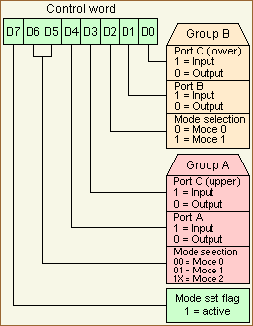
If bit 7 of the control word is a logical 0 then each bit of the port C can be set or reset.
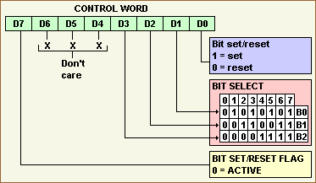

Q12.A) Draw and explain the interfacing of keyboard to 8085 microprocessor

Interfacing Keyboard
When a key is pressed, the binary reading of the key has no relationship to what it represents.
The keyboard and display device can be connected to 8085 through the interfacing device 8255. The 8255 has three ports A, B and C. Here in simple I/O mode, the pushbutton keyboard is connected to Port A as an input port and seven segment LED is connected to Port B as an output port. The ports address range from FCH to FFH. When a push button key is pressed, it bounces (makes & breaks contact) a few times before it makes a firm contact. To prevent multiple readings of the same key, it is necessary to debounce the key. The hardware solution to this problem is to use a key debounce circuit and the software solution is to wait for 10 to 20ms until the key is settled and check the key again.
The display circuit is connected to the Port B of 8255A. To display a digit, it is necessary to convert it into appropriate seven segment code of the LED. The appropriate binary code can be obtained from the look table stored in memory location.

Figure

Keyboard
The keys K₇-K₀ are tied high through 10K resistors, and when a key is pressed, the corresponding line is grounded. When all keys are open and 8085 reads port A, the reading on the data bus will be FFH.
For Eg: if K₇ is pressed, the output of the port A will be 0111 1111(7FH). This reading should be encoded into the binary equivalent of the digit ’7’ using software routines.
The subroutines KYCHK and KYCODE accomplish the task of checking a key pressed and encoding the key in appropriate binary format. The subroutines first check whether all keys are open. This prevents reading the same key repeatedly if someone were to hold the key for a long time. Then it checks for a key closure, debounces the key, and places the reading in accumulator. i.e when a key is pressed, it will check whether key has pressed and wait for 10-20ms for a key debounce. It also complements the accumulator contents for conversion.
The KYCODE converts (encodes) the pushed key to the binary key code. It establishes the relationship between the hardware and the number of the key. If key K₇ is pressed, the reading in the accumulator will be 1000 0000. The KYCODE routine sets the register C for the count of eight and immediately decrements the count to seven. The RAL in KYCODE places the bit D7 in the CY flag, and the next instruction checks for the carry flag. IF it is set, the key K₇ must be pressed, and the keycode ‘7’ is in the register C. If CY=0, the program loops back to check the next bit D₆.

Keyboard with 8279
8279 is a general purpose keyboard display controller that simultaneously drives the display of a system and interfaces a keyboard with the CPU. The key has been pressed and sends the code of the pressed key to the CPU. It also transmits the data received from the CPU to the display device. The keyboard is interfaced either in interrupt mode or polling mode. In interrupt mode, the processor is requested service only if a key pressed, otherwise the processor can proceed with its main task. In polling mode, CPU periodically checks the internal flag of 8279 to check any key pressure.
The 8279 is a hardware approach of interfacing a matrix keyboard and multiplexed display. The disadvantage of software approach is that the microprocessor is occupied for a considerable amount of time in checking the keyboard and refreshing the display. 8279 relieves the processor from these two tasks. The trade off between hardware and software approach is the production cost vs the processor time and software development cost.
The 8279 is a 40-pin device with two major segments: keyboard and display. Keyboard segment can be to a 64 key contact key matrix. Keyboard entries are debounced and stored in the internal FIFO memory; an interrupt signal is generated with each entry. THE display segment can provide a 16-character scanned display interface with such devices as LED’s. This segment has 16*8 RAM which can be used to read or write information for display purpose.

Interfacing
Figure
Lines RL7-RL₀ of 8279 are connected to the columns of the matrix keyboard and the output lines (A₃-A₀ and B3-B₀) are connected to drive the LED segments. The three scan lines are connected to the decoder, to generate eight decoded signals. And the six output lines of the decoder are connected as digit drivers to turn six seven segment LED. The 8279 has four scan lines and hence it can be decoded to generate 16 output lines to drive 16 displays. The data lines of 8279 are connected to the data bus of 8085, and the IRQ to RST5.5 of the system. Four signals RD, WR, CLK and RESET OUT are directly connected from 8085.
After initialization of 8279, the respective codes are sent to the display RAM to display any character. To read the keyboard, the 8279 scans the columns; if a key closure is valid, it loads the key code into the FIFO, and the IRQ line goes high to interrupt the system.

Q12.B) With a functional block diagram, explain the architecture of a typical microcontroller?
A: Microcontroller is a device which contains a microprocessor along with I/O ports and minimum memory in a single package or it is a microprocessor with integrated peripherals. It contains most of the components required to form a microprocessor system, so called a single chip microcomputer. And it also has the ability to do some control functions, so called as a microcontroller.
Block Diagram
Microprocessor
Peripherals like Timer
I/O Ports
ROM/RAM memory

Microcontrollers are primarily used to perform dedicated functions. Generally they include all the essential elements of a computer on a single chip: MPU, R/W memory, ROM and I/O lines. Most of the microcontrollers have an 8-bit word size , at least 64 bytes of R/W memory, and 1KB of ROM. The range of I/O lines vary from 16 to 40 lines.
A microcontroller (or MCU) is a computer-on-a-chip. It is a type of microprocessor emphasizing self-sufficiency and cost-effectiveness, in contrast to a general-purpose microprocessor. The only difference being in a microcontroller and a microprocessor is that a microprocessor has three parts - ALU, Control Unit and registers (like memory), but the microcontroller has additional elements like ROM, RAM etc.
In contrast to general-purpose CPUs, microcontrollers do not have an address bus or a data bus, because they integrate all the RAM and non-volatile memory on the same chip as the CPU. Because they need fewer pins, the chip can be placed in a much smaller, cheaper package.
Integrating the memory and other peripherals on a single chip and testing them as a unit increases the cost of that chip, but often results in decreased net cost of the embedded system as a whole.

A microcontroller is a single integrated circuit, commonly with the following features:
- central processing unit - ranging from small and simple 4-bit processors to sophisticated 32- or 64-bit processors
- input/output interfaces such as serial ports (UARTs)
- other serial communications interfaces like I²C, Serial Peripheral Interface and Controller Area Network for system interconnect
- peripherals such as timers and watchdog
- RAM for data storage
- ROM, EPROM, EEPROM or Flash memory for program storage
- clock generator - often an oscillator for a quartz timing crystal, resonator or RC circuit
- many include analog-to-digital converters

This integration drastically reduces the number of chips and the amount of wiring and PCB space that would be needed to produce equivalent systems using separate chips.

A microcontroller combines onto the same microchip:
- The CPU core
- Memory (both ROM and RAM)
- Some parallel digital I/O
The heart of the microcontroller is the CPU core.

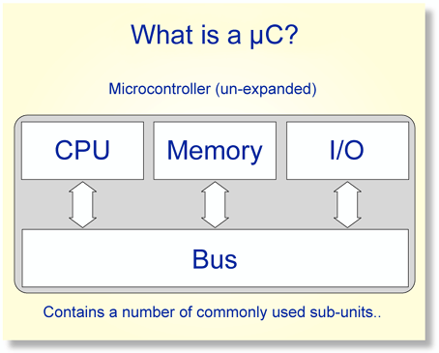
Most microcontrollers will also combine other devices such as:
- A Timer module to allow the microcontroller to perform tasks for certain time periods.
- A serial I/O port to allow data to flow between the microcontroller and other devices such as a PC or another microcontroller.
- An ADC to allow the microcontroller to accept analogue input data for processing.
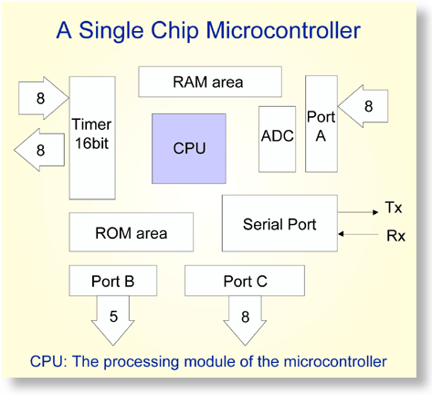

Q13.A) How the instruction set of 8086 is classified? Explain with example and instruction format?
Ans: 8086 instruction set is classified into 7 different groups
1. Data copy/transfer instruction set
2. Arithmetic instruction set
3. Logical instruction set
4. Control transfer or Branch instructions
5. Flag manipulation instructions
6. String manipulation instructions
7. Machine control or Input/output instructions
Data copy/transfer instruction set
These instructions are used to transfer or to copy the data from source to destination. Some examples are given below.
❖ MOV AX,BX
This instruction copies the value in the source operand to the destination operand. The source or destination can be register, memory location etc. But direct loading of data (using immediate data) is not possible.
This instruction will copy the content of register BX to the accumulator AX.
❖ LODSB/LODSW
Loads AL/AX with the byte/16-bit word pointed to by DS:SI, and updates SI depending on the direction flag. If DF is set SI is incremented (by 1 for 8-bit and by 2 for 16-bit), otherwise SI is decremented (by 1 or 2).

Arithmetic instruction set
These instructions are used to perform operations like addition, subtraction, multiplication, division, comparison etc.
❖ ADD AX,0100H
This will perform addition of source & destination operands and the result is stored in AX
❖ CBW
This is used to convert a signed byte (8-bit) to signed word (16-bit).
The byte is copied to AL and its sigh bit is copied to all bits in AH. Thus we get the result in AX.
Logical instruction set
These instructions are used to perform logical AND, OR, NOT, XOR etc.
    - AND
Performs a bitwise logical AND on the source and destination operands and stores the result in the destination operand
❖ NOT
Toggles each bit of the operand.
❖ OR
Performs a bitwise logical OR on the source and destination operands and stores the result to the destination operand.
❖ XOR
Performs a bitwise exclusive OR on the source and the destination operands, and stores the result in the destination operand.

Control transfer or Branch instructions
Using these instructions the flow of control is transferred to a different memory location which is specified directly or indirectly in the instruction. There are 2 types of Branch instructions.
1. Conditional 2. Unconditional
In conditional branch instructions, the control is transferred to the specified location only if some particular condition is satisfied whereas in unconditional branch instructions the control is transferred directly to the specified location without checking any condition.
❖ JNZ/JNE label
This is a conditional branch instruction. First it checks whether the zero flag is reset i.e., whether the answer is non-zero. If this condition is satisfied then the control is transferred to the location specified as label.
❖ CALL
This is an unconditional branch instruction. This will transfer the control to the specified location directly. When this is executed the IP and flag status are copied into the stack (for intrasegment) or the CS, IP and the flags for intersegment.

Flag manipulation instructions
This set contains the instructions used to modify the status of flags.
❖ CMC
This instruction is used to compliment the carry flag.
❖ STD
This instruction is used to set the direction flag.
❖ CLI
This instruction is used to clear the interrupt flag.

String manipulation instructions
These instructions are used to manipulate strings. A string can be either a byte (8-bit) or a word (16-bit). For these instructions the length is stored in CX register and is incremented or decremented accordingly depending on the direction flag.
❖ REP
This instruction is used as a prefix to a string instruction. Then the string instruction will be executed repeatedly [CX] times.
❖ SCASB/SCASW
This instruction is used to check whether a particular byte/word is present in the given string. The string will be in ES:DI and the byte/word to be searched is stored in AL/AX register.

Machine control or Input/output instructions
This set of instructions is used to control the bus usage and execution.
❖ ESC
This instruction will transfer data to the co-processor to perform some particular operations. A co-processor is a separate small processor used to perform specific tasks.
❖ LOCK
This instruction will lock co-processors or in other words it prevents other processors from accessing system bus when the processor is performing some critical operations.
Q.13.B) Explain the hardware interrupt operation through INTR pin of the 8086 processor in detail indicating how the interrupt system guides the processor in the appropriate service routine.
A:
While the CPU is executing a program,an interrupt breaks the normal sequence of execution of instructions and diverts it to the execution of some other program called the interrupt service routine(ISR). After executing the ISR , the control is transferred back again to the main program that was being executed at the time of interruption. Whenever a number of devices interrupt a CPU a time and if the processor is able to handle them properly , it is said to have multiple interrupt processing capability.
There are 2 types of interrupts: external and internal interrupts. The external interrupt , external device or a signal interrupts the processor from the outside or , in other words the interrupt is generated outside the processor , for eg: a keyboard interrupt.
The internal interrupt is generated internally by the processor circuit , or the execution of an interrupt instruction.the examples of this type are divive by zero interrupt, overflow interrupt, interrupts due to INT interrupt instructions . suppose an external device interrupts the CPU at the interrupt pin, either NMI or INTR of the 8086 while the CPU is executing an instruction of a program the CPU first completes the execution of the current instruction the IP is then incremented to point to the next instruction. The CPU the acknowledges the requesting device on INTA(active low) immediately if it is a NMI or TRAP or divide by zero interrupt .

Q 14(b i).Explain how is an 80286 switched from real address mode to protected virtual address mode operation. How can it be switched back to real address mode operation.

Q:The 80286 works in operating modes like real address mode and protected virtual address mode. In the real address mode the 80286 just acts a fast 8086. In PVAM, 80286 works with all of its memory management and protection capabilities. In PVAM 80286 is able to address 16MB of physical memory whereas virtual memory available is 1 GB. This complete virtual memory is mapped to the physical memory. Another important aspect is the data protection or unauthorized access prevention. When the 80286 is reset,it always starts its execution in real address mode,wherein it performs the following functions :it initializes the IP and other registers of 80286,initializes the peripheral, enables interrupts, sets up discreptor tables and then it prepares for entering the protected virtual address mode.In the protected mode ,Protected Virtual Address Mode (PVAM) OS or app must switch into PVAM and the processor must be RESET to switch from PVAM back to real mode .

Q 14(b ii).How can operating system kernel procedure be protected from access by application programmes in 80286?

A: Another important aspect of 80286 in its protected mode is the data protection or unauthorized access prevention. These concepts came from the segmented memory with
64 Kbyte pages and also setting access privilege in the descriptor tables.For example,the data lies in data segment , executable code lies in code segment and stack information lies in the stack segment.In case the stack data overlaps the executable code or the code segment overlaps the stack data,the complete program execution will lead to random results.Thus separation of these data types into logical segments is the first step towards data protection. Protected mode differed from the original mode of the 8086, which was later dubbed “real mode”, in that areas of memory could be physically isolated by the processor itself to prevent illegal writes to other programs running in memory at the same time. Prior to protected mode, multiple programs could be running in memory at the same time, but any program could access any area of memory and, therefore, if malicious activity occurs, it can take the whole system down.
In protected mode programming, it’s still possible to setup programs which have memory segments which overlap, but it’s rarely profitable to do so. As such, if an errant or malicious program attempts to do something it shouldn’t by accessing memory outside of the OS-assigned boundaries, then it will simply trigger a software interrupt (or internal CPU-generated interrupt) which will be serviced immediately, even before the current instruction is completed (because the current instruction was the one attempting to do the illegal thing), and an appropriate error handler is called via the interrupt service mechanisms.

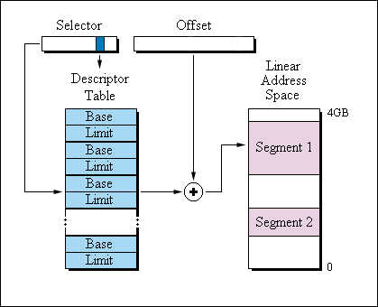

In PVAM , the 80286 uses the 16 bit content of e segment register as a selector to address a descriptor stored in physical memory . The descriptor is a block of contiguous memory locatons containing information of a segment , like segment base address , segment base limit,privilege level and so on. Thus using the base address of a segment and the segment limit , one can indicate the importance of the segment. Similarly , each segment has a type and its privilege level, which indicate the importance of the segment. A segment with lower privilege level will not be allowed to access another segment having higher privilege , thus offering protection to the segment from the unauthorised accesses.

15)A. With neat block diagram explain the basic features of the AMD processors. Compare it with Pentium?
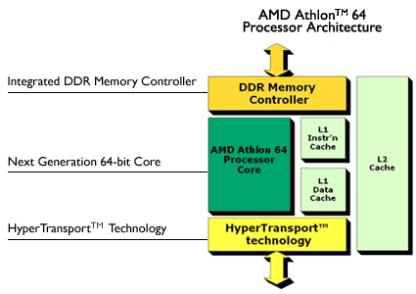
AMD Athlon 64
AMD64 provides full support for x86 code base for 32-bit computing and is ready for 64-bit applications. AMD64 technology doubles the number of processor registers and increases the system memory addressability

AMD Athlon™ 64 Processor Architecture
Key Architecture Innovations
The AMD Athlon™ 64 processor architecture integrates key system elements:

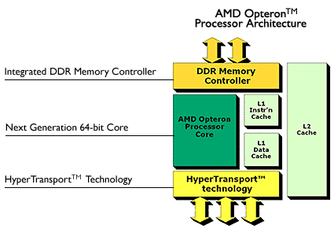

AMD Opteron
The AMD Opteron processor offers simultaneous 32- and 64-bit computing, using AMD's Direct Connect Architecture. It's designed to run existing 32-bit applications and offer simplified migration path to 64-bit computing. The AMD Opteron processor is available in 1 to 8-way servers and 1 to 4-way workstation solutions.
AMD Opteron™ Processor Architecture
Key Architecture Innovations
The AMD Opteron™ processor architecture integrates key system elements:
AMD Athlon 64 X2 Dual-Core
The AMD Athlon 64 X2 Dual-Core processor contains two processing cores, residing on one chip, which increases efficiency and speed while running multiple programs and multi-threaded software. It enables a seamless transition from 32-bit to 64-bit applications. Both 32- and 64-bit applications can run virtually simultaneously and transparently on the same platform 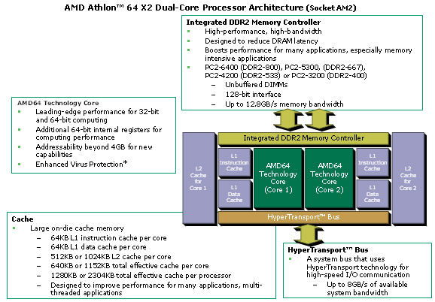

AMD Sempron
The AMD Sempron processor is designed to meet the needs of home and business PC users. AMD Sempron processors are 32-bit and offer capabilities that include HyperTransport technology, up to 512K total high-performance cache, advanced 333Mhz frontside bus and an integrated DDR memory controller.
Comparison b/w AMD and Pentium:
Both chips are very similar, but due to marketing, they seem very very different from each other. The primary "marketing" difference is the way they claim their speeds.
The Intel chipsets (Pentium, celeron) use MHz as a speed factor. IE "This Pentium 4 chip runs at 3000 MHz" (IE a Pentium 4 3.0).
The AMD chipsets do not use a MegaHertz rating for speed because they believe doing so would make their chips seem slower than their Intel counterparts. This is due to the difference in instruction set handling that AMD uses, and is too technical to really get into here. Instead you may see an AthlonXP 1600, etc. Apply the following formula to determine the "Pentium" equivalent MHz speed.
MHz = (XP rating/1.5) + (500/1.5)
For example, with an Athlon 1600, the math would break down like this: MHz = (1600/1.5) + (500/1.5) MHz = (1066.66) + (333.33) MHz = 1399.99
Which would be equivalent to the last incarnation of the Pentium 3 (at 1400 MHz).
Because Intel has enjoyed longer commercial success than AMD, you can typically find comparable AMD chips for half the cost. This has to do with brand loyalty and advertising costs as well as the types of memory used in both chips. Intel uses more expensive RDR RAM while the AMD chips use DDR RAM. That said, the RDR RAM is faster (533 MHz versus the 333 MHz of the DDR RAM) and helps to soften the blow of the cost of the chips to the consumer.

15.B) Explain in detail the segmented , paged virtual memory in 80386, indicating how segment base address with protection details is found and how the physical address is calculated.

A:) Protected Mode:
In protected mode, the processor addresses 4Gb of physical memory and 64TB of virtual memory. The addressing in protected mode is done with segment registers. The segment registers used as selectors to address descriptor. The address descriptor contains the segment limit, base address and access rights. The paging mechanism allows handling of large segments of memory in terms of 4KB segments. The paging unit converts the logical address to physical address in protected mode. And this paging unit works under the control of segment unit.
Virtual Mode ( V86 Mode)
Virtual 86 mode is a variation of protected mode. In its protected mode of operation, 80386 provide a virtual 8086 operating environment to execute 8086 instructions. Real mode can be used to execute 8086 instructions along with the capabilities of 80386. However, once it enters the protected mode from real mode, it cannot return back to the real mode without a reset operation. Thus, V86 mode of operation offers an advantage of executing 8086 instructions while in protected mode.
In real mode, 8086 can address 1MB of physical memory anywhere in 4GB address space of protected mode of 80386.Paging unit may be enabled in V86 mode. But it allows only 256 pages of size 4KB anywhere in 4GB.
The V86 mode executes all programs at privilege level 3. However, the real mode programs are executed in highest privilege level, level 0.In real mode; the instructions prepare the processor for protected mode which can only be done in highest privilege level.
The virtual mode is selected by the virtual mode (VM) bit in EFLAG register. V86 mode is enabled by switching the VM bit to 1. The virtual mode is entered by the instruction IRET. To return from V86 mode, any interrupt or exception can be used and VM bit is set to zero to pull back to protected mode. Virtual 86 monitor controls the switching between protected mode and virtual mode.

Memory Management
The 80386 transforms logical addresses (i.e., addresses as viewed by programmers) into physical address (i.e., actual addresses in physical memory) in two steps:
- Segment translation, in which a logical address (consisting of a segment selector and segment offset) are converted to a linear address.
- Page translation, in which a linear address is converted to a physical address.
These translations are performed in a way that is not visible to applications programmers.
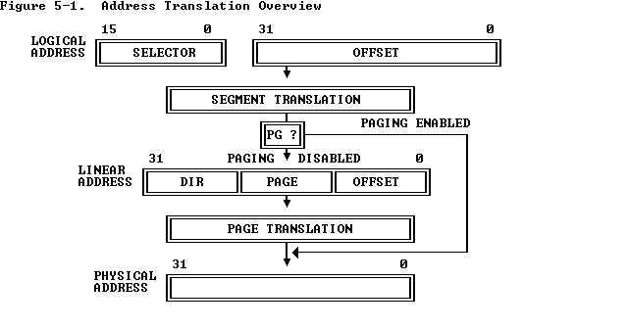

To perform this translation, the processor uses the following data structures:
- Descriptors
- Descriptor tables
- Selectors
- Segment Registers

Descriptors
The segment descriptor provides the processor with the data it needs to map a logical address into a linear address. Here, the access bytes are defined to indicate the stack and code segment description. Segment-descriptor fields are:

Base B₂₄- B₃₁ |  |  |  |  |  |  | G |  | D | 0 | A  V  L | LIMIT L₁₆- L19
P | DPL | S | E | X | RW | A |  | B₁₆- B₂₃
B₀- B₁₅
L₀- L₁₅

P=1: The segment is present.
S=1: Indicate data/Code descriptor.
S=0: System Descriptor
E: Executable- Selects data/Code segment
E=0: Data(Stack) segment
E=1: Code segment
X: Direction of expansion of Data segment.
X=0: Upward as data.
X=1: Downward as stack
RW: E=0 RW=1 DS may be written
E=0 RW=0 DS not written
E=1 RW=1 CS may read.
E=1 RW=0 CS not read
Accessed bit (A): The processor sets this bit each time the segment is accessed.

BASE: Defines the location of the segment within the 4 gigabyte linear address space. The processor concatenates the three fragments of the base address to form a single 32-bit value.
LIMIT: Defines the size of the segment. When the processor concatenates the two parts of the limit field, a 20-bit value results. The processor interprets the limit field in one of two ways, depending on the setting of the granularity bit:
- In units of one byte, to define a limit of up to 1 megabyte.
- In units of 4 Kilobytes, to define a limit of up to 4 gigabytes. The limit is shifted left by 12 bits when loaded, and low-order one-bits are inserted.
Granularity bit: Specifies the units with which the LIMIT field is interpreted. When the bit is clear, the limit is interpreted in units of one byte; when set, the limit is interpreted in units of 4 Kilobytes.
TYPE: Distinguishes between various kinds of descriptors.
DPL (Descriptor Privilege Level): Used by the protection mechanism
Segment-Present bit: If this bit is zero, the descriptor is not valid for use in address transformation; the processor will signal an exception when a selector for the descriptor is loaded into a segment register. The operating system is free to use the locations marked AVAILABLE. Operating systems that implement segment-based virtual memory clear the present bit in either of these cases:
- When the linear space spanned by the segment is not mapped by the paging mechanism.
- When the segment is not present in memory.

System Descriptor:
System descriptor defines information about the system tables, tasks and gates.

Base B₂₄- B₃₁ |  |  |  |  | G | D | 0 | A  V  L | LIMIT L₁₆- L19
P | DP | L | 0 | TYPE | B₁₆- B₂₃
B₀- B₁₅
L₀- L₁₅

Descriptor tables
The descriptor table defines all the segments used in the 80386 when it operates in the protected mode. There are three types of descriptor tables: the global descriptor table(GDT), local descriptor table (LDT) and an interrupt vector table(IDT). The registers used by the 80386 to address three tables are called Global descriptor table register(GDTR) the local descriptor table register(LDTR) and the interrupt descriptor table register(IDTR).

Segment descriptors are stored in either of two kinds of descriptor table:
- The global descriptor table (GDT)
- A local descriptor table (LDT)
A descriptor table is simply a memory array of 8-byte entries that contain descriptors. A descriptor table is variable in length and may contain up to 8192 (2^(13)) descriptors.

Selectors
The selector portion of a logical address identifies a descriptor by specifying a descriptor table and indexing a descriptor within that table
Index: Selects one of 8192 descriptors in a descriptor table. The processor simply multiplies this index value by 8 (the length of a descriptor), and adds the result to the base address of the descriptor table in order to access the appropriate segment descriptor in the table.
Table Indicator: Specifies to which descriptor table the selector refers. A zero indicates the GDT; a one indicates the current LDT.
Requested Privilege Level: Used by the protection mechanism.

Page Translation
In the second phase of address transformation, the 80386 transforms a linear address into a physical address. This phase of address transformation implements the basic features needed for page-oriented virtual-memory systems and page-level protection.
The page-translation step is optional. Page translation is in effect only when the PG bit of CR0 is set. This bit is typically set by the operating system during software initialization. The PG bit must be set if the operating system is to implement multiple virtual 8086 tasks, page-oriented protection, or page-oriented virtual memory.

Paging
The name "paging" was chosen since this indirection mechanism applied to 4KB chunks (or pages) of memory. Through the use of paging, operating systems can create distinct address spaces for each running application thus simplifying memory access and preventing potential conflicts.

Page Frame
A page frame is a 4K-byte unit of contiguous addresses of physical memory. Pages begin on byte boundaries and are fixed in size.

Linear Address
A linear address refers indirectly to a physical address by specifying a page table, a page within that table, and an offset within that page. 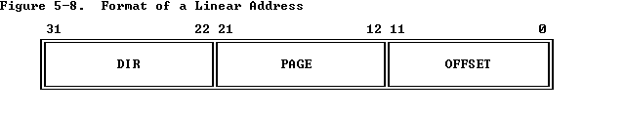
Processor converts the DIR, PAGE, and OFFSET fields of a linear address into the physical address by consulting two levels of page tables. The addressing mechanism uses the DIR field as an index into a page directory, PAGE field as an index into the page table determined by the page directory, and the OFFSET field to address a byte within the page determined by the page table.
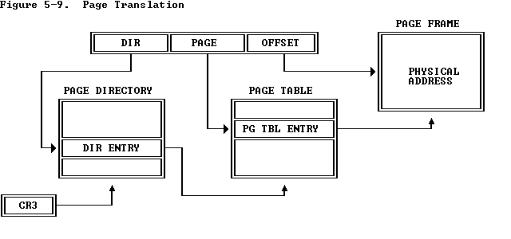

Page Tables
A page table is simply an array of 32-bit page specifiers. A page table is itself a page, and therefore contains 4 Kilobytes of memory or at most 1K 32-bit entries.
Two levels of tables are used to address a page of memory. At the higher level is a page directory. The page directory addresses up to 1K page tables of the second level. A page table of the second level addresses up to 1K pages. All the tables addressed by one page directory, therefore, can address 1M pages (2^(20)). Because each page contains 4K bytes 2^(12) bytes), the tables of one page directory can span the entire physical address space of the 80386 (2^(20) times 2^(12) = 2^(32)).
The physical address of the current page directory is stored in the CPU register CR3, also called the page directory base register (PDBR).

Page Frame Address
The page frame address specifies the physical starting address of a page. Because pages are located on 4K boundaries, the low-order 12 bits are always zero. In a page directory, the page frame address is the address of a page table. In a second-level page table, the page frame address is the address of the page frame that contains the desired memory operand.
The Present bit indicates whether a page table entry can be used in address translation. P=1 indicates that the entry can be used.
Addressing mode

Protection is provided in the way that a higher privilege level file cannot be accessed by a lower privilege level. Hence, all important data are provided in higher privilege levels. Also due to segmented memory arrangement provides higher security.

